1973 D
Discuss briefly the relationship between the dipole moment of a molecule and the polar character of the bonds within it. With this as the basis, account for the difference between the dipole moments of CH₂F₂ and CF₄.
Answer:
In order to have a dipole moment (i.e., to be a polar molecule) a molecule must have polar bonds and must have a molecular geometry which is not symmetrical (i.e., one in which the vector sum of the bond dipoles ≠ 0).
In CH₂F₂ the C-F and C-H bonds are polar and the molecule is not symmetrical; therefore, the molecules is polar and would show a dipole moment.
In CF₄ the C-F bonds are polar, but the molecule is symmetrical; therefore, the molecule is non-polar and would not show a dipole moment.

1974 D
The possible structures for the compound dinitrogen oxide are NNO and NON. By experimentation it has been found that the molecule of dinitrogen oxide has a non-zero dipole moment and that ions of mass 44, 30, 28, 16, and 14 are obtained in the mass spectrometer. Which of the structures is supported by these data? Show how the data are consistent with this structure.
Answer:
The correct structure is NNO. N-N=O; N-O bond di-pole; non-linear structure, non-symmetrical; molecular dipole moment.
Spectral Data (mass of molecular fragments):
44 = NNO 28 = NN 14 = N 30 = NO 16 = O
A fragment of 28 couldn’t be made if the structure was NON.

1974 D
The boiling points of the following compounds increase in the order in which they are listed below:
CH₄ < H₂S < NH₃
Discuss the theoretical considerations involved and use them to account for this order.
Answer:
CH₄ - weak London dispersion (van der Waals) forces
H₂S - London forces + dipole-dipole interactions
NH₃ - London + dipole + hydrogen bonding

1975 D
Suppose that a molecule has the formula AB₃. Sketch and name two different shapes that this molecule may have. For each of the two shapes, give an example of a known molecule that has that shape. For one of the molecules you have named, interpret the shape in the context of a modern bonding theory.
Answer:
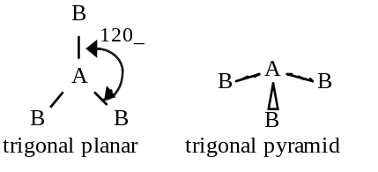
Example: trigonal planar, BF₃; trigonal pyramid, NH₃
For BF₃, the boron atom is surrounded by three pairs of electrons, the arrangement that will minimize the repulsions is a flat (planar) arrangement with the electron pairs furthest apart at 120º angles. OR
The NH₃ molecule has four pairs of electrons: three bonding pairs and one non-bonding pair. The best arrangement for four electron pairs is a tetrahedral structure (109.5º) with the lone (non-bonding) electron pair at the apex requiring more space than the bonding pairs, compressing the bonding pairs to an angle of 107º. The molecular structure is always based on the positions of the atoms, therefore it is a trigonal pyramid rather than a tetrahedron.

1976 D
NF₃ and PF₅ are stable molecules. Write the electron-dot formulas for these molecules. On the basis of structural and bonding considerations, account for the fact that NF₃ and PF₅ are stable molecules but NF₅ does not exist.
Answer:
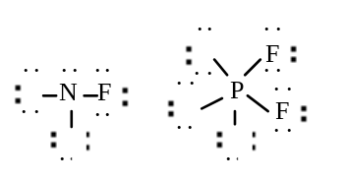
Describe the sp³ bonding for NF₃ and the sp³d for PF₅.
Nonexistence of NF₅ because of no low energy d orbital for N.

1978 D
State precisely what is meant by each of the following four terms. Then distinguish clearly between each of the two terms in part (a) and between each of the two terms in part (b), using chemical equations or examples where helpful.
(a) Bond polarity and molecular polarity (dipole moment)
(b) For a metal M, ionization energy and electrode potential.
Answer:
(a) Bond polarity - resulting from unequal sharing of electrons between bonding atoms; or from bonding of atoms with different electronegativities.
Molecular polarity - result of the separation of the centers of positive and negative charges in an entire molecule (The dipole moment is a measure).; or the result of the non-zero vector sum of bond dipoles and lone-pair electrons.
Distinction (normally included within the definitions).
(b) Ionization energy - energy required to remove an electron from an atom [if atom is described as gaseous or isolated - 1 additional point]
Electrode potential - related to energy associated with oxidation or reduction or associated with a tendency to gain or lose electrons.
A quantity measured relative to the hydrogen electrode or related to the energy changes in an electrochemical cell.
Distinction (normally included within the definitions).

1979 D
Draw Lewis structures for CO₂, H₂, SO₃ and SO₃²⁻ and predict the shape of each species.
Answer:
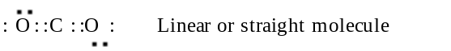
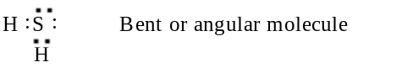
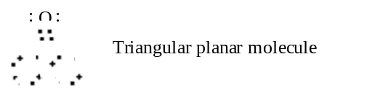
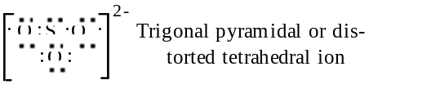

1979 D
Butane, chloroethane, acetone, and 1-propanol all have approximately the same molecular weights. Data on their boiling points and solubilities in water are listed in the table below.
Compound | Formula | Boiling Pt.(ºC) | Solubility in water
Butane | CH₃CH₂CH₂CH₃ | 0 | insoluble
Chloroethane | CH₃CH₂Cl | 12 | insoluble
Acetone | CH₃CCH₃ | 56 | completely miscible
1-Propanol | CH₃CH₂CH₂OH | 97 | completely miscible
On the basis of dipole moments (molecular polarities) and/or hydrogen bonding, explain in a qualitative way the differences in the
(a) boiling points of butane and chloroethane.
(b) water solubilities of chloroethane and acetone.
(c) water solubilities of butane and 1-propanol.
(d) boiling points of acetone and 1-propanol.
Answer:
(a) Butane is nonpolar; chloroethane is polar. Intermolecular forces of attraction in liquid chloroethane are larger due to dipole-dipole attraction; thus a higher boiling point for chloroethane.
(b) Both chloroethane and acetone are polar. However, acetone forms hydrogen bonds to water much more effectively than chloroethane does, resulting in greater solubility of acetone in water.
(c) Butane is non-polar and cannot form hydrogen bonds; 1-propanol is polar and can form hydrogen bonds. 1-propanol can interact with water by both dipole-dipole forces and hydrogen bonds. Butane can interact with water by neither means. Thus, 1-propanol is much more soluble.
(d) Acetone molecules are attracted to each other by van der Waals attraction and dipole-dipole attraction. 1-propanol molecules show these two types of attraction. However, 1-propanol can also undergo hydrogen bonding. This distinguishing feature results in the higher boiling point of 1-propanol.

1982 D
(a) Draw the Lewis electron-dot structures for CO₃²⁻, CO₂, and CO, including resonance structures where appropriate.
(b) Which of the three species has the shortest C-O bond length? Explain the reason for your answer.
(c) Predict the molecular shapes for the three species. Explain how you arrived at your predictions.
Answer:
(a)
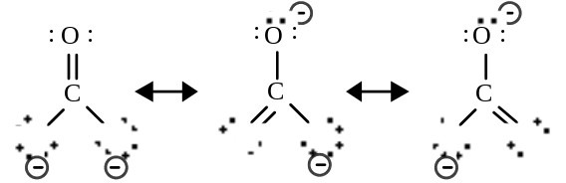
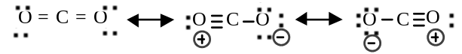
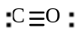
(b) CO has the shortest bond because there is a triple bond. OR because there is the greatest number of electrons between C and O in CO.
(c) CO₃²⁻ trigonal planar (planar and triangular). C bonding is sp² hybrid - or - C has three bonding pairs and no lone pair.
CO₂ linear. C bonding is sp hybrid - or - C has two bonding pairs and no lone pairs - or - CO₂ is nonpolar and must be linear.
CO linear. Two atoms determine a straight line.

1982 D
The values of the first three ionization energies (I₁, I₂, I₃) for magnesium and argon are as follows:
 | I₁ | I₂ | I₃
 | (kJ/mol)
Mg | 735 | 1443 | 7730
Ar | 1525 | 2665 | 3945
(a) Give the electronic configurations of Mg and Ar.
(b) In terms of these configurations, explain why the values of the first and second ionization energies of Mg are significantly lower than the values for Ar, whereas the third ionization energy of Mg is much larger than the third ionization energy of Ar.
(c) If a sample of Ar in one container and a sample of Mg in another container are each heated and chlorine is passed into each container, what compounds, if any, will be formed? Explain in terms of the electronic configurations given in part (a).
(d) Element Q has the following first three ionization energies:
 | I₁ | I₂ | I₃
 | (kJ/mol)
Q | 496 | 4568 | 6920
What is the formula for the most likely compound of element Q with chlorine? Explain the choice of formula on the basis of the ionization energies.
Answer:
(a) Mg: 1s² 2s²2p⁶ 3s¹
Ar: 1s² 2s²2p⁶ 3s²3p⁶
(b) Valence electrons for Mg and Ar are in the same principal energy level, but Ar atom is smaller and has a greater nuclear charge. Thus, ionization energies for Mg are less than those for Ar. Removal of third electron from Mg atom is from n = 2 level and electrons in this level experience strong nuclear attraction.
(c) Only MgCl₂ forms. Mg atoms readily lose 2 valence electrons each. Ionization energy for third electron very high. Electron affinity for Ar is low, and ionization energies for Ar atoms are high.
(d) Formula is QCl. Very high second ionization energy indicates that there is only one valence electron.

1985 D
Substance Melting Point, ºC
H₂ -259
C₃H₈ -190
HF -92
CsI 621
LiF 870
SiC >2,000
(a) Discuss how the trend in the melting points of the substances tabulated above can be explained in terms of the types of attractive forces and/or bonds in these substances.
(b) For any pairs of substances that have the same kind(s) of attractive forces and/or bonds, discuss the factors that cause variations in the strengths of the forces and/or bonds.
Answer:
(a) H₂ and C₃H₈ have low melting points because the forces involved were the weak van der Waals (or London) forces.
HF has a higher melting point because intermolecular hydrogen bonding is important.
CsI and LiF have still higher melting points because ionic lattice forces must be overcome to break up the crystals, and the ionic forces are stronger than van der Waals forces and hydrogen bonds.
SiC is an example of a macromolecular substance where each atom is held to its neighbors by very strong covalent bonds.
(b) C₃H₈ and H₂: There are more interactions per molecule in C₃H₈ than in H₂. OR C₃H₈ is weakly polar and H₂ is nonpolar.
LiF and CsI: The smaller ions in LiF result in a higher lattice energy than CsI has. Lattice energy U is proportional to 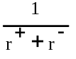.

1988 D
Using principles of chemical bonding and/or intermolecular forces, explain each of the following.
(a) Xenon has a higher boiling point than neon has.
(b) Solid copper is an excellent conductor of electricity, but solid copper chloride is not.
(c) SiO₂ melts at a very high temperature, while CO₂ is a gas at room temperature, even though Si and C are in the same chemical family.
(d) Molecules of NF₃ are polar, but those of BF₃ are not.
Answer:
(a) Xe and Ne are monatomic elements held together by London dispersion (van der Waals) forces. The magnitude of such forces is determined by the number of electrons in the atom. A Xe atom has more electrons than a neon atom has. (Size of the atom was accepted but mass was not.)
(b) The electrical conductivity of copper metal is based on mobile valence electrons (partially filled bands). Copper chloride is a rigid ionic solid with the valence electrons of copper localized in individual copper(II) ions.
(c) SiO₂ is a covalent network solid. There are strong bonds, many of which must be broken simultaneously to volatilize SiO₂. CO₂ is composed of discrete, nonpolar CO₂ molecules so that the only forces holding the molecules together are the weak London dispersion (van der Waals) forces.
(d) In NF₃ a lone pair of electrons on the central atom results in a pyramidal shape. The dipoles don’t cancel, thus the molecule is polar.
While in BF₃ there is no lone pair on the central atom so the molecule has a trigonal planar shape in which the dipoles cancel, thus the molecule is nonpolar.

1989 D
CF₄ XeF₄ ClF₃
(a) Draw a Lewis electron-dot structure for each of the molecules above and identify the shape of each.
(b) Use the valence shell electron-pair repulsion (VSEPR) model to explain the geometry of each of these molecules.
Answer:
(a)
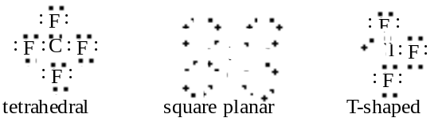
(b) CF₄ = 4 bonding pairs around C at corners of regular tetrahedron to minimize repulsion (maximize bond angles).
XeF₄ = 4 bonding pairs and 2 lone pairs give octahedral shape with lone pairs on opposite sides of Xe atom
ClF₃ = 3 bonding pairs and 2 lone pairs give trigonal bipyramid with one pairs in equatorial positions 120º apart.

1989 D
The melting points of the alkali metals decrease from Li to Cs. In contrast, the melting points of the halogens increase from F₂ to I₂.
(a) Using bonding principles, account for the decrease in the melting points of the alkali metals.
(b) Using bonding principles, account for the decrease in the melting points of the halogens.
(c) What is the expected trend in the melting points of the compounds LiF, NaCl, KBr, and CsI? Explain this trend using bonding principles.
Answer:
(a) Alkali metals have metallic bonds: cations in a sea of electrons. As cations increase in size (Li to Cs), charge density decreases and attractive forces (and melting points) decrease.
(b) Halogen molecules are held in place by dispersion (van der Waals) forces: bonds due to temporary dipoles caused by polarization of electron clouds. As molecules increase in size (F₂ to I₂), the larger electron clouds are more readily polarized, and the attractive forces (and melting points) increase.
(c) Melting point order: LiF > NaCl > KBr > CsI
Compounds are ionic. Larger radii of ions as listed. Larger radii -> smaller attraction and lower melting points.

1990 D (Required)
Use simple structure and bonding models to account for each of the following.
(a) The bond length between the two carbon atoms is shorter in C₂H₄ than in C₂H₆.
(b) The H-N-H bond angle is 107.5º, in NH₃.
(c) The bond lengths in SO₃ are all identical and are shorter than a sulfur-oxygen single bond.
(d) The I₃⁻ ion is linear.
Answer:
(a) C₂H₄ has a multiple bond; C₂H₆ has a single bond. Multiple bonds are stronger and, therefore, shorter than single bonds.
(b) NH₃ has 3 bonding pairs of electrons and 1 lone pair. Bonding pairs are forced together because repulsion between lone pair and bonding pairs is greater than between bonding pairs.
(c) The bonding in SO₃ can be described as a combination of 3 resonance forms of 1 double and 2 single bonds.
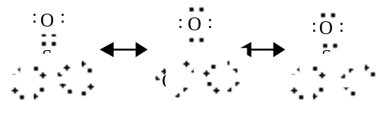
The actual structure is intermediate among the 3 resonance forms, having 3 bonds that are equal and stronger (therefore, shorter) than an S-O single bond.
(d) The central I atom has 3 lone pairs and 2 bonding pairs around it. 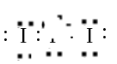
To minimize repulsion, the 3 lone pairs on the central atom are arranged as a triangle in a plane are right angles to the I-I-I- axis.

1991 D
Experimental data provide the basis for interpreting differences in properties of substances.
TABLE 1
Compound | Melting Point (ºC) | Electrical Conductivity of Molten State (ohm⁻¹)
BeCl₂ | 405 | 0.086
MgCl₂ | 714 | > 20
SiCl₄ | -70 | 0
MgF₂ | 1261 | > 20

TABLE 2
Substance | Bond Length (angstroms)
F₂ | 1.42
Br₂ | 2.28
N₂ | 1.09
Account for the differences in properties given in Tables 1 and 2 above in terms of the differences in structure and bonding in each of the following pairs.
(a) MgCl₂ and SiCl₄ (c) F₂ and Br₂
(b) MgCl₂ and MgF₂ (d) F₂ and N₂
Answer:
(a) MgCl₂ is IONIC while SiCl₄ is COVALENT. The electrostatic, interionic forces in magnesium chloride are much stronger then the intermolecular (dispersion) forces in SiCl₄ and lead to a higher melting point for MgCl₂. Molten MgCl₂ contains mobile ions that conduct electricity whereas molten SiCl₄ is molecular, not ionic, and has no conductivity.
(b) MgF₂ has a higher melting point than MgCl₂ because the smaller F⁻ ions and the smaller interionic distances in MgF₂ cause stronger forces and higher melting point.
(c) The bond length in Br₂ is larger than in F₂ because the Br atom is bigger (more shells) than the F atom.
(d) The bond length in N₂ is less than in F₂ because the N≡N bond is triple and the F-F is single. Triple bonds are stronger and therefore shorter than single bonds.

1992 D
Explain each of the following in terms of atomic and molecular structures and/or intermolecular forces.
(a) Solid K conducts an electric current, whereas solid KNO₃ does not.
(b) SbCl₃ has measurable dipole moment, whereas SbCl₅ does not.
(c) The normal boiling point of CCl₄ is 77ºC, whereas that of CBr₄ is 190ºC.
(d) NaI(s) is very soluble in water, whereas I₂(s) has a solubility of only 0.03 gram per 100 grams of water.
Answer:
(a) K conducts because of its metallic bonding - or – “sea” of mobile electrons (or free electrons). KNO₃ does not conduct because it is ionically bonded and has immobile ions (or immobile electrons).
(b) SbCl₃ has a measurable dipole moment because it has a lone pair of electrons which causes a dipole - or - its dipoles do not cancel - or - it has a trigonal pyramidal structure - or - a clear diagram illustrating any of the above.
(c) CBr₄ boils at a higher temperature than CCl₄ because it has stronger intermolecular forces (or van der Waal or dispersion). These stronger forces occur because CBr₄ is larger and/or has more electrons than CCl₄.
(d) NaI has greater aqueous solubility than I₂ because NaI is ionic (or polar), whereas I₂ is non-polar (or covalent). Water, being polar, interacts with the ions of NaI but not with I₂. (Like dissolves like accepted if polarity of water is clearly indicated.)

1992 D
NO₂ NO₂⁻ NO₂⁺
Nitrogen is the central atom in each of the species given above.
(a) Draw the Lewis electron-dot structure for each of the three species.
(b) List the species in order of increasing bond angle. Justify your answer.
(c) Select one of the species and give the hybridization of the nitrogen atom in it.
(d) Identify the only one of the species that dimerizes and explain what causes it to do so.
Answer:
(a) 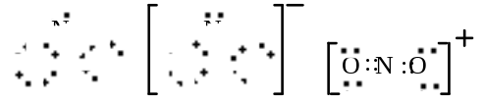
(b) NO₂⁻ < NO₂ < NO₂⁺
NO₂⁻ - 3 charge centers around N; lone pair of electrons on N
NO₂ - 3 charge centers around N; single electron on N
NO₂⁺ - 2 charge centers on N
(c) NO₂⁺ is linear, has sp hybridization - or - NO₂/NO₂⁻ have sp² hybridization
(d) NO₂ will dimerize, because it contains an odd electron that will pair readily with another, forming N₂O₄.

1994 D
Use principles of atomic structure and/or chemical bonding to answer each of the following.
(a) The radius of the Ca atom is 0.197 nanometer; the radius of the Ca²⁺ ion is 0.099 nanometer. Account for this difference.
(b) The lattice energy of CaO(s) is -3,460 kilojoules per mole; the lattice energy for K₂O(s) is -2,240 kilojoules per mole. Account for this difference.
 | Ionization Energy (kJ/mol)
 | First | Second
K | 419 | 3,050
Ca | 590 | 1,140
(c) Explain the difference between Ca and K in regard to
(i) their first ionization energies,
(ii) their second ionization energies.
(d) The first ionization energy of Mg is 738 kilojoules per mole and that of Al is 578 kilojoules per mole. Account for this difference.
Answer:
(a) The valence electrons in a calcium atom are the 4s². In a calcium ion these electrons are absent and the highest energy electrons are 3p, which has a much smaller size because the (-)/(+) charge ratio is less than 1 causing a contraction of the electron shell.
(b) Lattice energy can be represented by Coulomb’s law: lattice energy = k 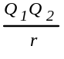, where Q₁ and Q₂ are the charges on the ions, in CaO these are +2 and -2 respectively, while in K₂O they are +1 and -2. The r (the distance between ions) is slightly smaller in CaO, combined with the larger charges, thus accounts for the larger lattice energy.
(c) Electron arrangements: K = [Ar] 4s¹, Ca = [Ar] 4s²
(i) Potassium has a single 4s electron that is easily removed to produce an [Ar] core, whereas, calcium has paired 4s electrons which require greater energy to remove one.
(ii) a K⁺ ion has a stable [Ar] electron core and requires a large amount of energy to destabilize it and create a K²⁺ ion. Ca⁺ has a remaining 4s¹ electron that is more easily removed than a core electron, but not as easily as its first 4s electron.
(d) Electron arrangements,
Mg = [Ne] 3s², Al = [Ne] 3s², 3p¹
It is easier to remove a shielded, single, unpaired 3p electron from the aluminum than to remove one electron from a paired 3s orbital in magnesium.

1995 D (Required)
The conductivity of several substances was tested using the apparatus represented by the diagram below.
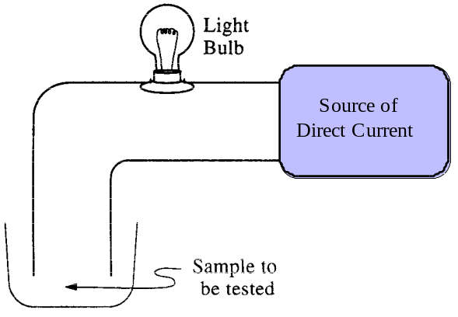
The results of the tests are summarized in the following data table.
 | AgNO₃ | Sucrose | Na | H₂SO₄ (98%)
Melting Point (ºC) | 212º | 185º | 99º | Liquid at Room Temp.
Liquid (fused) | ++ | - | ++ | +
Water Solution | ++ | - | ++⁽¹⁾ | ++⁽²⁾
Solid | - | - | ++ | Not Tested
Key: | ++ Good conductor
 | + Poor conductor
 | - Nonconductor
(1) Dissolves, accompanied by evolution of flammable gas
(2) Conduction increases as the acid is added slowly and carefully to water
Using models of chemical bonding and atomic or molecular structure, account for the differences in conductivity between the two samples in each of the following pairs.
(a) Sucrose solution and silver nitrate solution.
(b) Solid silver nitrate and solid sodium metal.
(c) Liquid (fused) sucrose and liquid (fused) silver nitrate.
(d) Liquid (concentrated) sulfuric acid and sulfuric acid solution.
Answer:
(a) Sucrose, composed of all non-metals, is a covalently bonded molecule that does not ionize in water and, therefore, does not produce a conducting solution. Silver nitrate has an ionic bond between the silver cation and the nitrate anion that is hydrated in water producing a conducting ionic solution.
(b) Silver nitrate has covalent bonds in the nitrate anion and an ionic bond between the cation and anion but in the solid state these ions are not free to move and conduct an electric current. In sodium, a metal crystal, it has a large number of closely spaced molecular orbitals that form a virtual continuum of levels called bands. Empty molecular orbitals are close in energy to filled molecular orbitals. Mobil electrons are furnished when electrons in filled molecular orbitals are excited into empty ones. These conduction electrons are free to travel throughout the metal crystal
(c) Fused sucrose does not contain any ions to carry an electrical charge whereas the ions in silver nitrate are now free to move in the liquid and conduct the charge.
(d) Concentrated sulfuric acid has very little water to hydrolyze its ions and is only slightly ionized. As it is added to water, appreciable amounts of ions are present as the molecular H₂SO₄ is dissociated into hydrogen and sulfate ions.

1995 D
Explain the following in terms of the electronic structure and bonding of the compounds considered.
(a) Liquid oxygen is attracted to a strong magnet, whereas liquid nitrogen is not.
(b) The SO₂ molecule has a dipole moment, whereas the CO₂ molecule has no dipole moment. Include the Lewis (electron-dot) structures in your explanation.
(c) Halides of cobalt(II) are colored, whereas halides of zinc(II) are colorless.
(d) A crystal of high purity silicon is a poor conductor of electricity; however, the conductivity increases when a small amount of arsenic is incorporated (doped) into the crystal.
Answer:
(a)
N₂ O₂
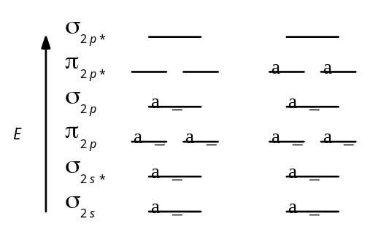
Molecular Orbital Energy Level Diagrams
Paramagnetism causes a substance to be attracted into the inducing magnetic field. Paramagnetism is associated with unpaired electrons, as in oxygen but diamagnetism (repelled from the inducing magnetic field) is associated with paired electrons as in nitrogen. Any substance that has both paired and unpaired electrons will exhibit paramagnetism, since that effect is stronger than diamagnetism.
(b)
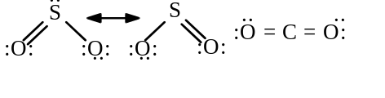
There is a dipole moment between the oxygen and the sulfur in sulfur dioxide and a bond angle of 119º. This results in a net dipole in the molecule. While there is a dipole in the carbon-oxygen bond, the 180º bond angle cancels the dipole moment in the molecule.
(c) A cobalt(II) ion has the electron configuration of [Ar] 3d⁷. It has 2 paired d electrons and 3 unpaired electrons. According to crystal field theory, as the chloride ion approaches the cobalt(II) ion, repulsion between the chloride lone pairs and the metal electrons affects the metal d orbitals differently (the x²-y² and z² more than the xy, xz, and yz). There is an energy difference between the sets of d orbitals. The energy difference between sets of d orbitals is comparable to the energy of visible light. In zinc ions, all the d orbitals are paired and all the orbitals are degenerate.
(d) Arsenic atoms have one more valence electron than silicon atoms and can lose an electron to form As⁺ ions which can occupy some of the lattice points in the silicon crystal. If the amount of arsenic is kept small then these ions don’t interact. The extra electrons from the arsenic occupy orbitals in a narrow band of energies that lie between the filled and empty bands of the silicon. This structure decreases the amount of energy required to excite an electron into the lowest-energy empty band in the silicon and increases the number of electrons that have enough energy to cross this gap.

1996 D
Explain each of the following observations in terms of the electronic structure and/or bonding of the compounds involved.
(a) At ordinary conditions, HF (normal boiling point = 20ºC) is a liquid, whereas HCl (normal boiling point = -114ºC) is a gas.
(b) Molecules of AsF₃ are polar, whereas molecules of AsF₅ are nonpolar.
(c) The N-O bonds in the NO₂⁻ ion are equal in length, whereas they are unequal in HNO₂.
(d) For sulfur, the fluorides SF₂, SF₄, and SF₆ are known to exist, whereas for oxygen only OF₂ is known to exist.
Answer:
(a) hydrogen bonding (dipole-dipole attraction) is much larger in HF than in HCl.
(b) AsF₃ forms a pyramidal shaped molecule with a lone pair of electrons creating an asymmetrical region opposite the three highly electron-affinitive fluorine in the base. The AsF₅ molecule has a highly symmetrical trigonal bipyramidal shape with no lone electron pairs.
(c) The N-O bonds in the nitrite ion are stabilized by resonance and are of equal length, but in HNO₂, with a hydrogen attached to an oxygen, resonance is no longer possible.
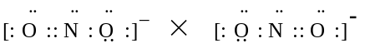
(d) There are only four orbitals in the valence shell of oxygen, one s and three p’s. As a result, oxygen can hold no more than eight valence electrons, which it gets when it forms OF₂. The valence orbitals of sulfur are in the n = 3 shell and includes empty d orbitals that can be used to expand its valence shell. Sulfur has 10 valence electrons in forming SF₄ and 12 valence electrons to form SF₆ (sp³d² hybrid orbitals).

1997 D (Required)
Consider the molecules PF₃ and PF₅.
(a) Draw the Lewis electron-dot structures for PF₃ and PF₅ and predict the molecular geometry of each.
(b) Is the PF₃ molecule polar, or is it nonpolar? Explain.
(c) On the basis of bonding principles, predict whether each of the following compounds exists. In each case, explain your prediction.
(i) NF₅
(ii) AsF₅
Answer:
(a) PF₃ = tripod (pyramid); PF₅ = trigonal bipyramid
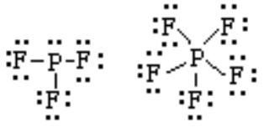
(b) polar; net dipole moment toward the non-symmetrical position of the fluorines.
(c) (i) NF₅ - doesn’t exist, nitrogen can’t hybridize to form the dsp³ orbitals and is also too small to accommodate 5 fluorine atoms around it.
(ii) AsF₅ - does exist, arsenic can hybridize to form the dsp³ orbitals and is large enough to accommodate 5 fluorine atoms around it.

1998 D
Answer each of the following using appropriate chemical principles.
(c) Dimethyl ether, H₃C-O-CH₃, is not very soluble in water. Draw a structural isomer of dimethyl ether that is much more soluble in water and explain the basis of its increased water solubility.
In each case, justify your choice.
Answer
(c) 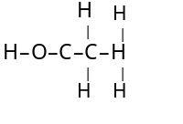The O-H bond in ethyl alcohol is very polar and will allow the molecule to be attracted to and dissolve in the polar water.

1999 B
2. Answer the following questions regarding light and its interactions with molecules, atoms, and ions.
(a) The longest wavelength of light with enough energy to break the Cl–Cl boned in Cl2(g) is 495 nm.
(i) Calculate the frequency, in s–1, of the light.
(ii) Calculate the energy, in J, of a photon of the light.
(iii) Calculate the minimum energy, in kJ mol–1, of the Cl–Cl bond.
(b) A certain line in the spectrum of atomic hydrogen is associated with the electronic transition of the H atom from the sixth energy level (n = 6) to the second energy level (n = 2).
(i) Indicate whether the H atom emits energy or whether it absorbs energy during the transition. Justify your answer.
(ii) Calculate the wavelength, in nm, of the radiation associated with the spectral line.
(iii) Account for the observation that the amount of energy associated with the same electronic transition (n = 6 to n = 2) in the He+ ion is greater than that associated with the corresponding transition in the H atom.
Answer
(a) (i) c = λν ; ν = = =
= 6.06x1014 waves/sec
(ii) ΔE = hν
= (6.63x10–34 joule.s)(6.06x1014 s–1)
= 4.02x10–19 J
(iii) (4.02x10–19 J)(6.02x1023 mol–1) =
= 241,870 J = 242 kJ
(b) (i) emits energy. The n = 6 state is at a higher energy than n = 2, the electron must release energy go to the lower state.
(ii) E2 = = –5.445x10–19 J
E6 = = –6.05x10–20 J
ΔE = E6 – E2 = 4.84x10–19 J
OR
ΔE = –2.178x10–18 ( – ) J = 4.84x10–19 J
OR
λ = ; ν = =
= 7.30x1014 sec–1
λ = = = 4.11x10–7 m
OR
λ = =
= 411 nm
(iii) the He+ has a nuclear charge of 2+ vs H with a 1+, therefore, it has a stronger hold on the electron. This requires more energy for the electron to move to higher energy levels and when the electron moves from higher to lower energies, it releases more energy.

1999 D
8. Answer the following questions using principles of chemical bonding and molecular structure.
(a) Consider the carbon dioxide molecule, CO2, and the carbonate ion, CO32–.
(i) Draw the complete Lewis electron-dot structure for each species.
(ii) Account for the fact at the carbon-oxygen bond length in CO32– is greater than the carbon-oxygen bond length in CO2.
(b) Consider the molecules CF4 and SF4.
(i) Draw the complete Lewis electron-dot structure for each molecule.
(ii) In terms of molecular geometry, account for the fact that the CF4 molecule is nonpolar, whereas the SF4 molecule is polar.
Answer
(a) (i)  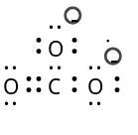, there are two other similar resonance structures for the carbonate ion.
(ii) the pi O=C double bond in CO2 is shorter than a single O-C resonance sigma-bond (all are identical and are about 1 1/3 bond) found in a carbonate ion.
(b) (i) 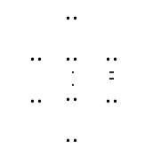 
(ii) in the tetrahedral CF4, the polar C-F bonds are cancelled out by the equiangular pull of the 4 bonds. With an expanded octet and trigonal bipyramidal structure, SF4 has a pair of unbonded electrons at the center of the bipyramid, this gives a “seasaw” shape to the molecule and an uneven pull to the polar S-F bonds.
